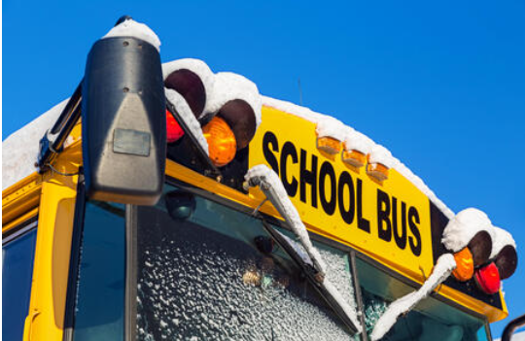
November 20, 2023

Alternate School Bus Routes - Nelson Area

Winter is approaching! In preparation for this, School District 8 has identified some areas within the district where, due to grade and topography, the service by a school bus during events of severe winter weather would place students and staff at an unacceptable level of risk.
Any changes to regular bus routes will be posted on the following;
- Announcements on the SD8 Website
- Announcements on the School Website
- Facebook
Below are some pre-determined alternate school bus stop locations and pick up or drop off times, in case of a severe winter event in the Nelson Area.

For all students living on Longbeach Road:
- The morning stop location for Route 19 – Shark
7:33 AM - North Bound-Hwy 3A and Upper Longbeach Road North; (students to stand at the bottom of Upper Longbeach Road and cross the highway with the bus lights and stop arm).

- The afternoon stop location for Route 16 – Moose (Redfish Students)
2:13 PM - Hwy 3A and Longbeach Road North

- The afternoon stop location for Route 18 – Octopus (Trafalgar & LVR Students)
4:22 PM - Hwy 3A and Upper Longbeach Road North

For students living in the 49th Creek & Marello Road area:
- The morning bus stop for Route 22 - Giraffe
7:40 AM – Blewett Rd & Carlson Rd.

- The afternoon stop location for Route 22 – Giraffe (Blewett Students)
2:44 PM – Blewett Rd & Carlson Rd

- The afternoon stop location for Route 22 – Giraffe (Trafalgar & LVR Students)
4:02 PM – Blewett Rd & Carlson Rd
*Please ensure to leave space for the bus to drop students off and turn around at Carlson Rd

More information is available through the School District website at www.sd8.bc.ca.

If you require any further information, please contact the School District No. 8 Nelson Transportation Department at 250-354-4871.

Sincerely,

Patrick Thast
District Transportation Coordinator
School District No. 8

